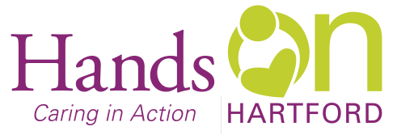
FACILITY/TENANT ASSISTANT
Wanted: Versatile individual to join our team at Hands On Hartford as a Facility/Tenant Assistant providing tenants of 55 Bartholomew Avenue with a safe, secure environment as well as assistance to scattered site tenants, to help all maintain good health and stable housing.
When: 30 hours per week position, 3rd shift, 10p-8am Thursday-Saturday.
Pay: $17-$21 per hour.

Why work at Hands On Hartford: Hands On Hartford, located in the vibrant Parkville neighborhood of Hartford, in partnership with others, strengthens community in Hartford by responding faithfully to people in need through programs that change lives and renew human possibility. We’re a 54-year-old non-profit that values diversity, team work, and takes a strengths’ based, collaborative approach to all we do.
As a Facility/Tenant Assistant, you will do many things including but not limited to:
- Maintain a safe and secure environment for all tenants of 55 Bartholomew Avenue.
- Assist tenants with health care involvement, access to nursing services and medication supports as needed.
- Work to avert and manage crisis and other emergency situations.
- Provide services in a culturally competent manner and uphold elements of trauma sensitive care.

You may be a good fit if you:
- Believe in our mission and core values and are committed to diversity, equity and inclusion.
- Have a minimum of high school diploma or GED plus at least 1-year related experience.
- Have a demonstrated knowledge, interest, and experience in services/issues related to HIV, homelessness, substance abuse and mental illness.
- Have a demonstrated ability and experience engaging/supporting individuals in crisis management.
- Have knowledge and proficiency in using computer applications, including standard Windows applications.
- Have a valid driver’s license and ability to lift and carry at least 25 pounds.
- Ability to remain on duty until new staff arrives during inclement weather.

What we offer full time employees:
- Generous medical/dental/disability/life benefits.
- Dedicated, diverse, and friendly co‐workers.
- Paid time off –holidays, vacation, personal time, and sick leave.
- 401 K contribution and employer match.
- Free on-site parking
If this sounds like a good fit to you:
Send letter of interest and resume to: Liz Pantoja, Program Manager Housing Services
Hands On Hartford, 55 Bartholomew Ave, Hartford CT 06106.
Email: lpantoja@handsonhartford.org
Closing date: 06/15/24
AA/EOE

