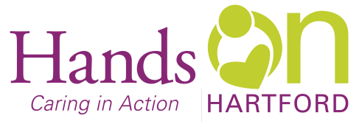
Backpack and Pantry Program Liaison
Wanted: Versatile individual to join our team at Hands On Hartford as a Backpack and Pantry Program Liaison working closely with Volunteers and Food and Nutrition staff to provide and expand food distribution to low-income individuals and families who reside in Hartford through the Community Pantry and the Backpack Nutrition program. A special focus of this position will be in the Backpack Program.
Why work at Hands On Hartford: Located in the vibrant Parkville neighborhood of Hartford, in partnership with others, strengthens community in Hartford by responding faithfully to people in need through programs that change lives and renew human possibility. We’re a 54-year-old nonprofit that values diversity, team work, and takes a strength based, collaborative approach to all we do.
When: Full time Monday – Friday. A minimum of 2 holidays per year and occasional evening and weekend.
Pay: Range $19-$26 per hour. This is an hourly position.
As the Backpack and Pantry Program Liaison, you will work with Volunteers and Food Access staff to provide and expand food distribution to low-income individuals and families who reside in Hartford through the Community Pantry and the Backpack Nutrition Program. You will Assist with the selection, packing, transportation and storage of food for Food Pantry and Backpack Nutrition Program. You will receive donations of food and assist in the orderly storage, presentation and distribution of the donations in the backpack and pantry areas. In addition, you will process Food Pantry intakes and review documentation to determine eligibility for food pantry clients. You will be coordinating and supporting volunteer efforts and help them feel part of the Neighborhood Services/Community Pantry, Backpack Nutrition Program and Garden teams.
Qualifications:
- This position requires fluency in English and conversational Spanish.
- The ideal candidate will have proficiency in Microsoft Word, Excel, Outlook and other Microsoft products.
- A valid driver’s license.
- Ability to lift and carry up to 75 lbs.
What we offer full time employees:
- Dedicated, diverse, and friendly co‐workers
- Paid time off – 12 holidays, +vacation, +personal time, + sick leave
- 401(k) employer contribution and employer match
- Free on-site parking
If this sounds like a good fit to you, send letter of interest & resume to:
Jennica Torres, Manager of Homeless Prevention and Food Access
Hands On Hartford, 55 Bartholomew Ave, Hartford CT 06106.
Email: jtorres@handsonhartford.org
AA/EOE

